# Linux Commands Part II

1. Elevate your user access to root;

sudo -i

1. add a new user to your Linux OS and set a password for it;

sudo adduser user2

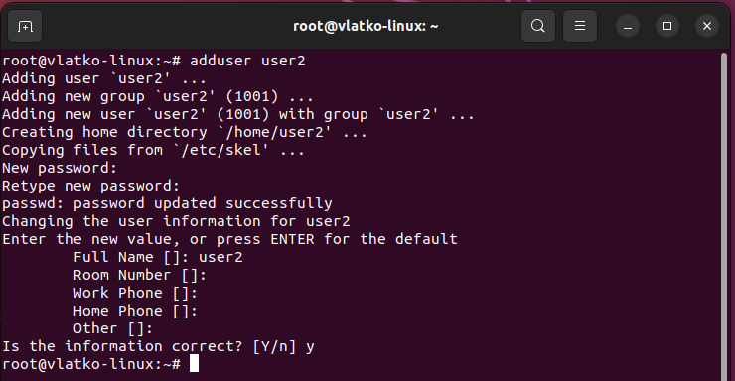

1. Test if you can log in using that user;

su -l user2

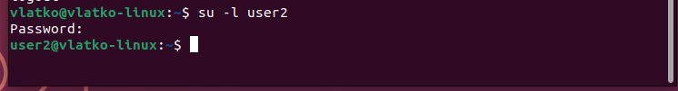

1. Using grep command check if the user is created;

grep user2 /etc/passwd

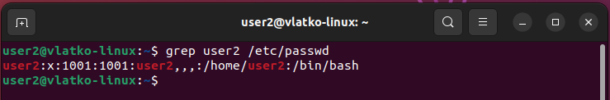

1. grep the UID of each user;
2. Find out the GID of the created user;

cat /etc/passwd | grep user2 | cut -d: -f4



1. Change the password of the user and force it to change the pass on his next login;

sudo passwd -e user2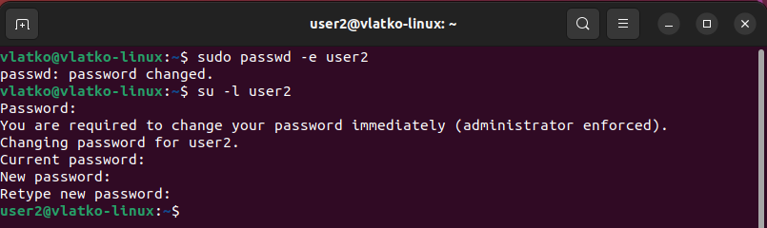

1. Add a new user and set an expiration date for it, with a five-day warning period;

sudo useradd -e `date -d “5 days” +”%Y-%m-%d”` trial1



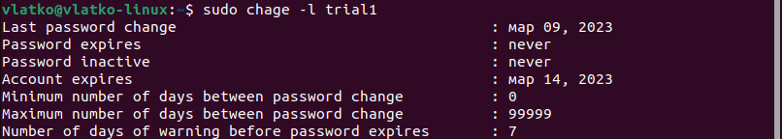

1. Create a new group;

sudo groupadd mygroup



1. Assign the two new users to that group;

sudo usermod -a -G mygroup user2

sudo usermod -a -G mygroup trial1



1. Lock one of the user accounts;

sudo passwd -l trail1



1. Change the shell of one user to tcsh;

sudo usermod –shell /bin/csh user2

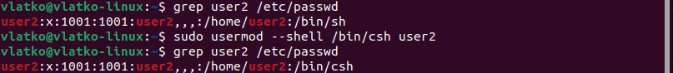

1. Make sure your home directory has “execute” access enabled for group and other.

Sudo chmod ug+x /home



1. Change to your home directory, and create a directory called labs

cd /home

sudo mkdir labs



1. Create an empty file in labs directory

sudo touch epmtyFile



1. Change permissions of file to rwx-rwx

sudo chmod 770 emptyFIle



1. List the file. What color is the file?

Green

1. Change the permissions back to rx-rw-rw

sudo chmod 666 emptyFile



1. Check what owners does the file have.

ls -l emptyFile

1. Change the user ownership of the file to another user;

sudo chown user2 emptyFile



1. Create a group called group1 and assign two users to the group;

sudo groupadd group1

sudo usermod -a -G group1 user2

sudo usermod -a -G group1 trial1

1. Create a file called group1.txt and redirect below input into the file:

“This is our group test file”.

sudo echo ‘This is our group test file.’ >> group1.txt



1. Change the group of the file to one of your users;

sudo chgrp user2 group1.txt



1. Give members of the group group1 read/write access to this file?